NBA Database



Brian Tracey

Professor Labouseur

Database Management

26 April 2016

Table of Contents

Table of contents 2

Executive summary 3

entity relatinship diagram 4

Tables 5

reports 27

views 30

stored procedures 32

Trigger 34

security 35

implementation notes 37

known problems 38

future enhancements **39**

*Executive Summary*

This database keeps a record of all former and current players and teams in the National Basketball Association. It holds each player’s stats, which teams each player has played for and when, and a player’s draft selection and year. It also keeps track of teams wins and losses, game stats and rosters and coaches for each season.

This database is to be used by fans that want to keep a log of his or her team or favorite players. The following pages include an entity relationship diagram, information about the tables within the database, security permissions and examples of certain stored procedures, views, reports and triggers.

*Entity Relationship Diagram*



*Tables*

People Table

The People Table holds basic information such as first and last name and birth date. This table will be expanded into coaches and players.

Functional Dependencies

PID -> FirstName, LastName, BirthDate

Create Statement

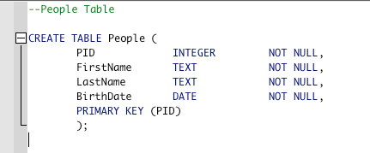

People Output

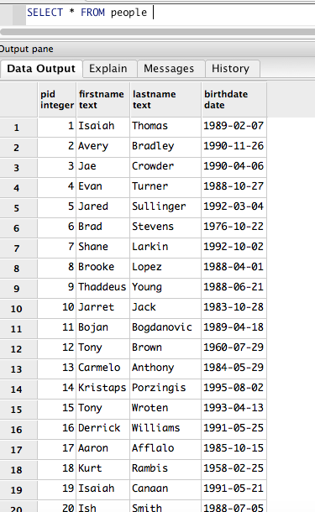

Player Table

The player table is a sub table of the people table. It specifies which people are players and includes his draft year, selection, height and weight.

Functional Dependencies

PID -> DraftYear, Selection, HeightIN, WeightLBS

Create Statement

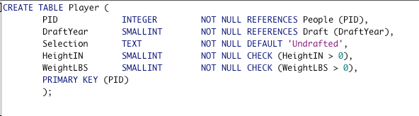

Player Output

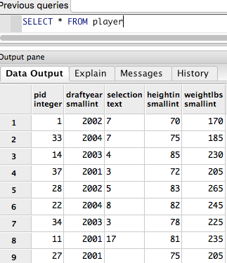

Player_For Table

The Player_For table shows which player has player for what teams and when he was signed and when the contract (with that team) ended. It also includes his jersey numbers.

Functional Dependencies

PID, TeamID -> SignedDate, EndDate, JerseyNumber

Create Statement

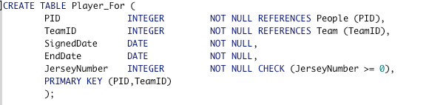

Player For Output

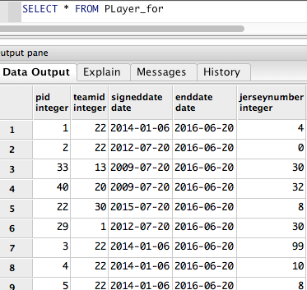

Player Position Table

The Players_Position Table is a weak entity table the links a player to his position.

Functional Dependencies

None

Create Statement

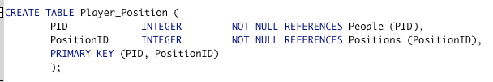

Player_Position Output

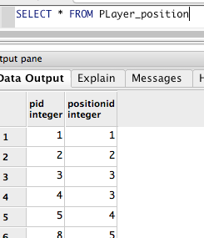

Position Table

The Position Table lists out the five positions a player can be; Point Guard, Shooting Guard, Small Forward, Power Forward, Center.

Functional Dependencies

PositionID-> PositionName

Create Statement

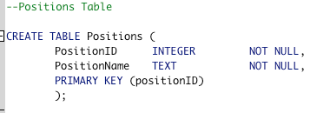

Positions Output

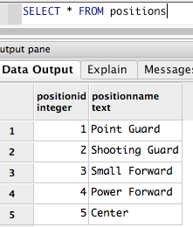

Draft Table

The Draft table includes the draft year as the primary key and will show the first selection and the team that selected him for that draft year.

Functional Dependencies

DraftYear -> TeamID, PID, Selection

Create Statement

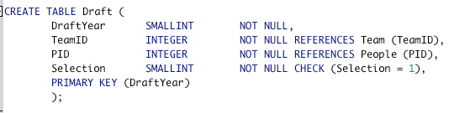

Draft Output

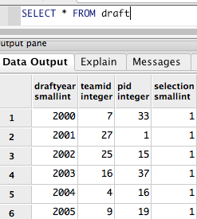

Coach Table

The Coach Table is an extension of the People table but for coaches.

Functional Dependencies

PID -> FirstYear

Create Statement

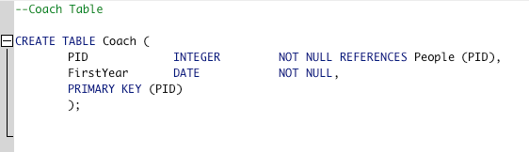

Coach Output

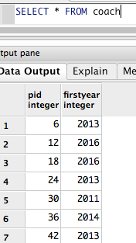

Coach Of Table

The Coach Of table links the coach to the team he coaches along with his start and end date.

Functional Dependencies

PID , TeamID -> StartDate, EndDate

Create Statement

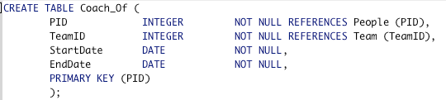

Coach Of Output

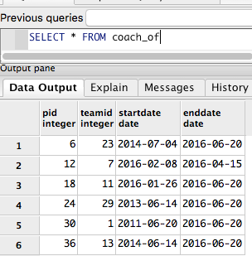

Arena Table

The Arena Table shows what arena teams play in. This can show fans of the game, which teams play well in what arenas.

Functional Dependencies

ArenaID -> City, Name

Create Statement

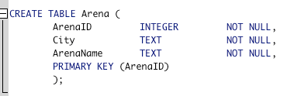

Arena Output

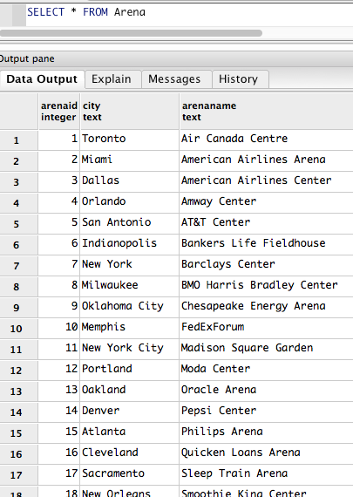

Division Table

The Division Table shows which teams are in which division and which conference. This can be useful if users of the database want to see the standings and who will make playoffs.

Functional Dependencies

DivisionID -> DivisionName, Conference, TimeZone

Create Statement

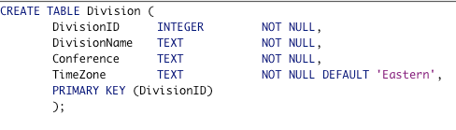

Division Output

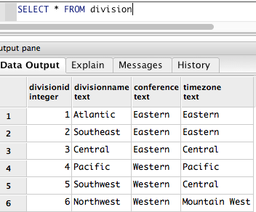

Team Table

The team table lists each team in the NBA. This is necessary to show the rosters for each team, who coaches each team and then stats and results of games. This is one of the more primary tables in the database.

Functional Dependencies

TeamID -> ArenaID, DivisionID, TeamCity, TeamName

Create Statement

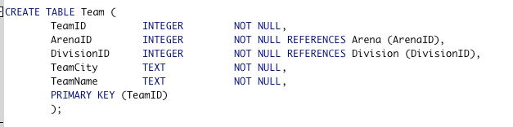

Team Output

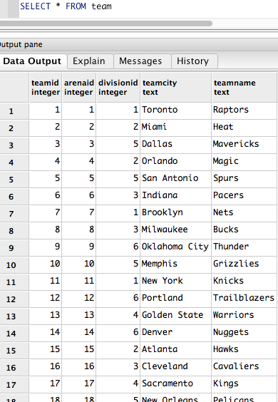

Season Champion Table

This table is necessary to show the NBA Champion for each season.

Functional Dependencies

ChampionID -> SeasonID, TeamID

Create Statement

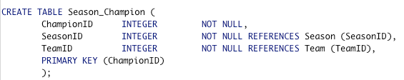

Season Champion Output

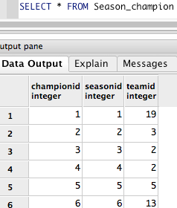

Season Table

The Season Table lists out each season’s start date and end date. This is necessary to show which team won a championship for that season.

Functional Dependencies

SeasonID -> StartDate, EndDate

Create Statement

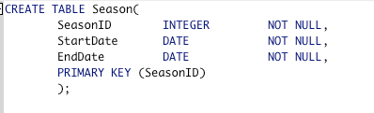

Season Output

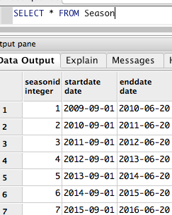

Game Table

The Game Table lists out the games played in each season. It has the two teams playing, one as home team and one as away team and which arena it is played in. it also includes the date. The games table gets broken down into a previous games table and then a future games table.

Functional Dependencies

GameID -> SeasonID, ArenaID, HomeTeamID, AwayTeamID, DatePlayed

Create Statement

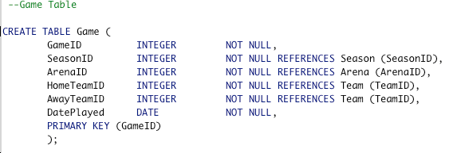

Game Output

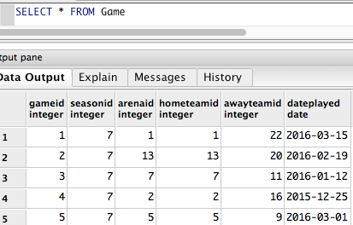

Previous Game Table

This table shows that a game has already been played. It is an extension of the Game table. It then links this game to include stats for both players and teams.

Functional Dependencies

None

Create Statement

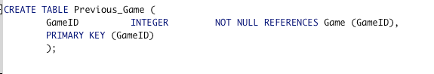

Previous Game Output

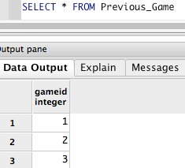

Future Game Table

This table shows that a will be played in the future. It is an extension of the Game table.

Functional Dependencies

None

Create Statement

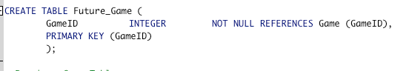

Future Game Output

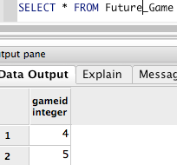

Player Stats Table

This table shows the stats each player has recorded in games he has played.

Functional Dependencies

PID, GameID -> Minutes, FGA, FGM, FGPercent, ThreePointPercent, FreeThrowPercent, TurnOver, Assists, Rebounds, Points

Create Statement

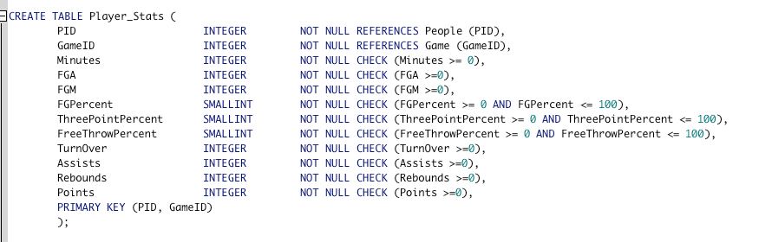

Player Stats Output

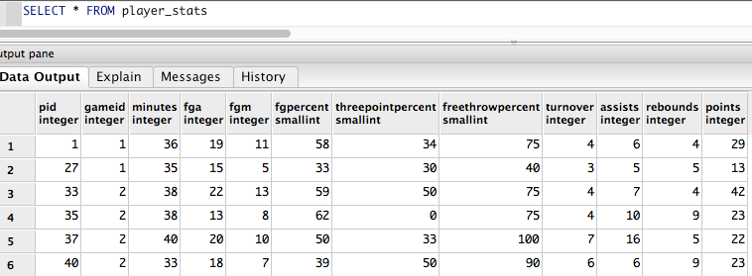

Team Stats Table

This table shows the stats a team had in each game they have played.

Functional Dependencies

TeamID, GameID -> Result, Score, FGPercent, ThreePointPercent, FreeThrowPercent, TurnOver, Assists, Rebounds

Create Statement

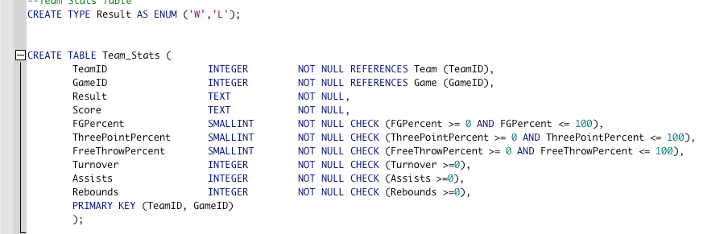

Team Stats Output

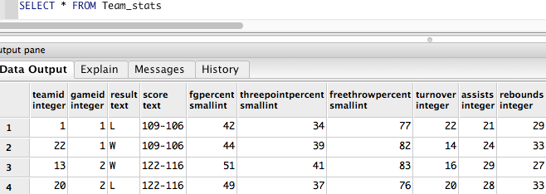

*Reports*

First Report

The First report will show the years within one season.

Statement

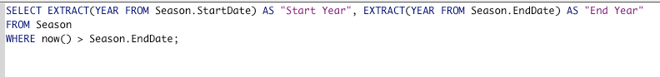

Output

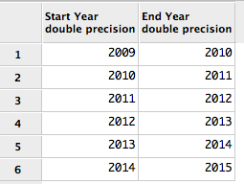

Second Report

The second report returns the list of coaches in the league, their date of birth and the team they coach.

Statement

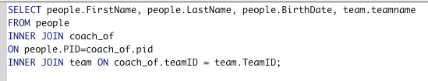

Output

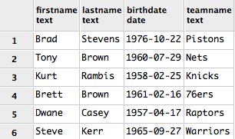

Third Report

The third report lists players in the league and their current team.

Statement

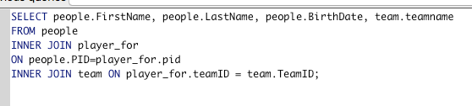

Output

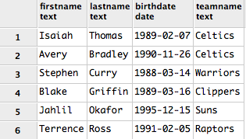

*Views*

First View

The first view statement allows the user to see a Team’s Arena name, sorted by alphabetical order.

Statement

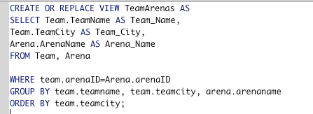

Output

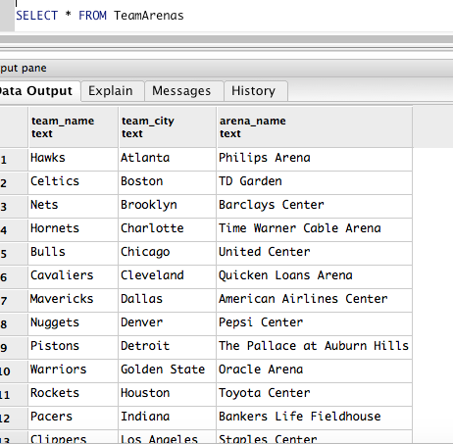

Second View

The Second view allows a user to see a player’s points scored.

Statement

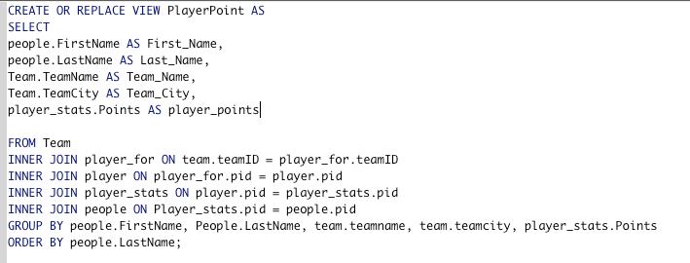

Output

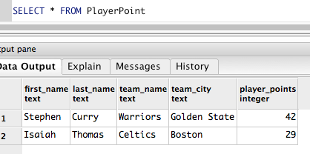

*Stored Procedures*

First Procedure

The First stored procedure allows a user to select a player by position.

Statement

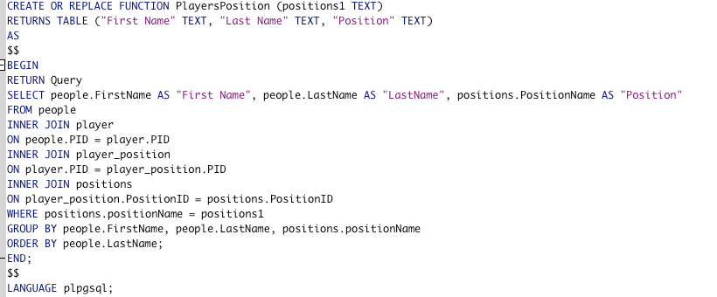

Output

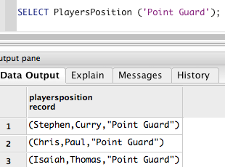

Second View

The Second View allows a user to select a team and see the current roster for that team.

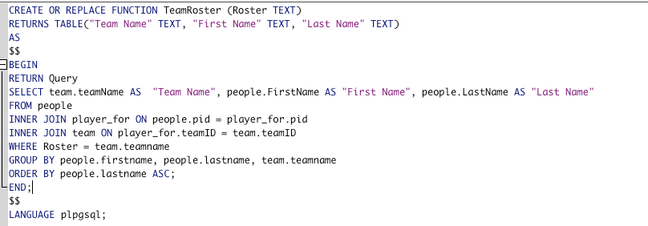Statement

Output

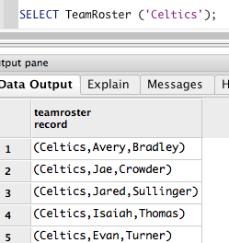

*Trigger*

This trigger checks the old jersey number when updating a new jersey number for a player.

Statement

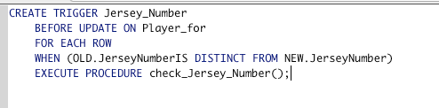

*Security*

Database Admin Role

This role allows the database administrator to do anything he or she wants, including updating, deleting or inserting data into tables and revoking privileges.

Statement

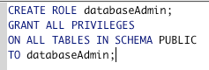

General Admin Role

This role allows a general administrator to do things such as update rosters and update the games table.

Statement

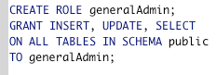

Public User Role

This role allows a public user to select the information they are looking for from the database.

Statement

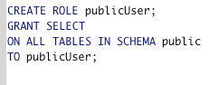

*Implementation Notes*

* This database is strictly used for the National Basketball Association.
* Some queries will be needed to find the information. Not all information is readily available on hand.
* The draft table only shows the first selection of that draft year. However, you can find the selection of any player and the year he was drafted by joining other tables.

*Known Problems*

* One of the main problems of this database is that an admin will have to update the end dates for players and coaches if he is on the team in the beginning of each year.
* Another main problem is that you cannot calculate the total amount of points a team has scored throughout the season.

*Future Enhancements*

* I would like to include a playoffs table to be able to see playoffs from previous years.
* I would also like the change the team stats tables to have the scores in two separate columns. These columns would now be integers and you could total points and look at efficiencies.
* I would also like to make the draft table include all selections so it is easier to see drafts by year.